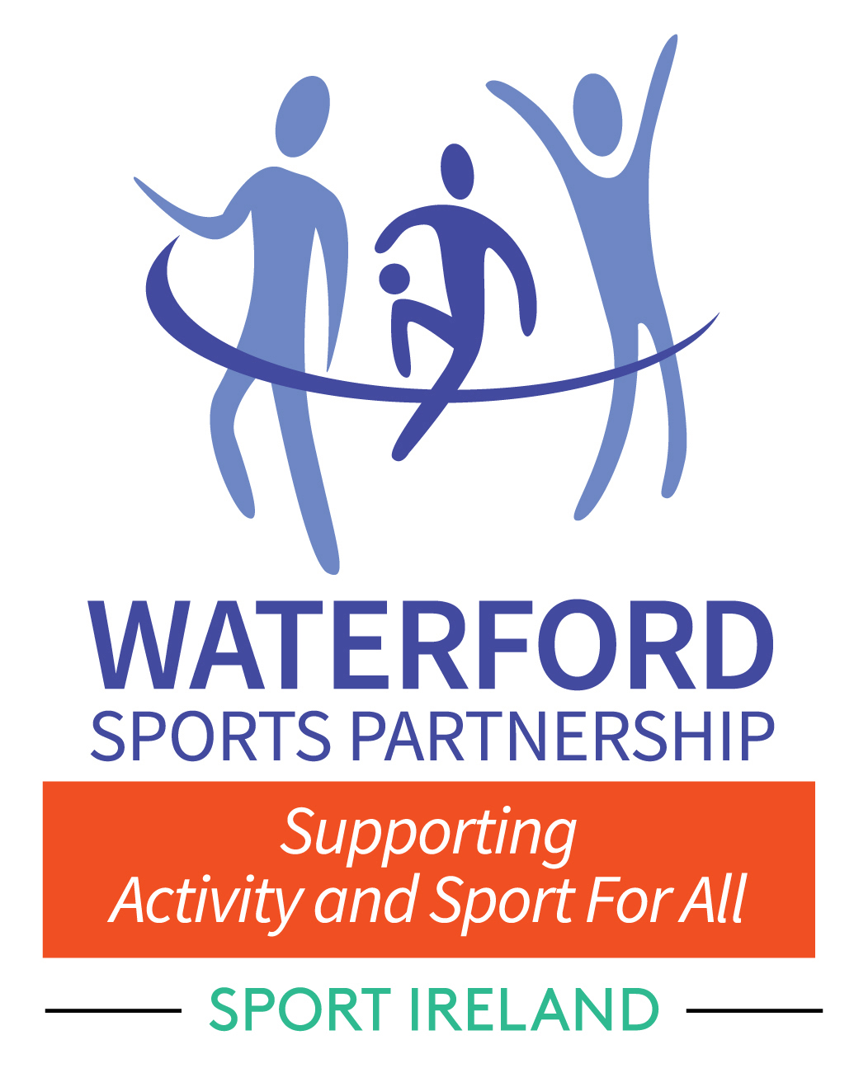

## **Waterford Sports Partnership**

## **Club Grant 2022** APPLICATION FORM *Please read the Grant Criteria carefully before completing this Form.*

|  |  |  |  |  |  |  |  |
| --- | --- | --- | --- | --- | --- | --- | --- |
| **1. APPLICANT DETAILS** | |  | | | | | |
| Name of Club: | |  | | | | | |
| Club Address/Location: | |  | | | | | |
| Club Website Address: | |  | | | | | |
| Club Facebook Address: | |  | | | | | |
| Treasurer: | |  | | | | | |
| Secretary: | |  | | | | | |
| ***DETAILS OF CORRESPONDENCE PERSON FOR CLUB*** | | | | | | | |
| Name: |  | | | | | | |
| Position in Club: |  | | | | | | |
| Mobile Number: |  | | | | | | |
| Email: |  | | | | | | |
| **2. BANK ACCOUNT DETAILS:** Any payments will be processed directly to the Club Bank Account. Please provide the following details: | | | | | | | | |
| Name of Bank: | |  | | | | | | |
| Address of Bank: | |  | | | | | | |
| Account Name: | |  | | | | | | |
| Account Number: | |  | | | | | | |
| BIC*:* | |  | | | | | | |
| IBAN: | |  | | | | | | |
| Signed by Authorised Signatory | |  | | | | | | |
| **3. AFFILIATION** | | | | | |
| (i) Is your club/organisation affiliated to a National Governing Body (NGB)? YES NO | | | | | |
| (ii) If yes, please state name of NGB: | |  | | | |
| (iii) If you are a disability group and not affiliated to an NGB, please state below which National Disability  organisation you are affiliated to: | | | | | |
|  | | | | | |
| (iv) Has your club signed up to the CARA Sport Inclusion Disability Charter? YES NO For more information please see - https://caracentre.ie/sport-inclusion-disability-charter/ | | | | | |
| (iv) Is your club/organisation a member of Waterford Public Participation Network (PPN)?  *This is a requirement for all grant applications*  Contact: Muriel Tobin, Waterford PPN on 058 21198 YES NO | | | | | |
| **4. CHILD PROTECTION/GARDA VETTING** | | | | | |
| (i) Have all coaches and volunteers who work with underage  individuals/teams completed safeguarding training? YES NO | | | | | |
| (ii) Have all coaches and volunteers who work with underage  individuals/ teams been garda vetted? YES NO | | | | | |
| (iii) If you answered ‘NO’ to either of the above questions,  do you commit to ensuring safeguarding training and garda vetting  will be completed if successful? YES NO | | | | | |
| **5. GRANT DETAILS** | | | | | | |
| (1) Are you a new club? YES   NO   | | | | | | | | | |
| (2) **If ‘yes’, when was the club formed and registered with NGB?**  *(Please attach written confirmation from your NGB)* | | | | | | | | | |
|  | | | | | | | | | |
| (3) **Describe the proposed project**  ***Please include target groups and outline of project including dates (****use additional sheets if necessary)* | | | | | | | | | |
|  | | | | | | | | | |
|  | | | | | | | | | |
|  | | | | | | | | | |
| **(4) How will this project increase participation?** | | | | | | | | | |
|  | | | | | | | | | |
|  | | | | | | | | | |
|  | | | | | | | | | |
| **(5) How will the participation be sustained?** | | | | | | | | | |
|  | | | | | | | | | |
|  | | | | | | | | | |
|  | | | | | | | | | |
| **(6) What are the associated costs of this project?**  *Please be aware that you will need to provide receipts to drawdown full funding*  *.* | | | | | | | | | |
| **Cost Area** | | | | | **Amount** | | | | |
|  | | | | |  | | | | |
|  | | | | |  | | | | |
|  | | | | |  | | | | |
| **TOTAL** | | | | | **€** | | | | |
| **DECLARATION** | | | | | | | | | | |
| I hereby certify that I have read and understand the Waterford Sports Participation Club Grant Criteria and that the information supplied on this application is complete, correct, and accurate in every respect and it is on that basis only that this application is submitted for consideration and accepted for consideration by Waterford Sports Partnership. I further understand that the submission of any incorrect or inaccurate information will render the application null and void. | | | | | | | | | | |
| **SIGNED:** (on behalf of club/organisation) | | |  | **POSITION** | | | | | | |
| **NAME** | | |  | **AGE 16 to 20**  **AGE 21+** | | | | | | |
| **NAME (Block Capitals):** | | |  | **DATE:** | | | | | | |
|  | | |  |  | | | | | | |

**IMPORTANT CHECKLIST**

**Please Ensure that you enclose the following with your application**



Club Safeguarding StatementClub COVID-19 Safety Statement   
NGB/Disability Organisation Affiliation Letter/Email (Essential Requirement for ‘New’ clubs)





**IF YOU HAVE ANY QUESTIONS OR FOR MORE INFORMATION PLEASE CONTACT:** Sinéad Brannigan, Community Sports Development Officer on 087 459 6179

**Completed application forms can be returned by post or   
SUBMITTED online VIA LINK ON WSP WEBSITE.   
STRICTLY NO EMAIL APPLICATIONS WILL be ACCEPTED.**

WSP Club Development Grant

Waterford Sports Partnership, Regional Sports Centre, Cork Road, Waterford.

www.waterfordsportspartnership.ie

**CLOSING DATE FOR RECEIPT OF APPLICATIONS   
IS 5PM ON TUESDAY 31st MAY 2022**

**The decision of the committee is final**

