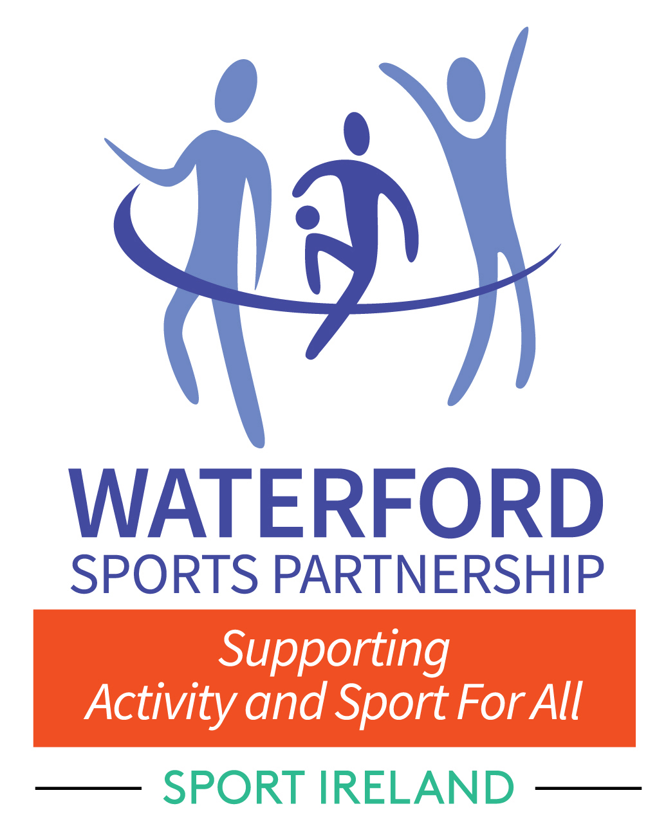

Waterford Sports Partnership

Club Grant 2019
APPLICATION FORM
Please read the Grant Criteria carefully before completing this Form.

1. APPLICANT DETAILS
Name of Club/Organisation:
Club Address/Location:
Club Web/Facebook Address:
Treasurer:
Secretary:
DETAILS OF CORRESPONDENCE PERSON FOR CLUB
Name:
Position in Club:
Mobile Number:
Email:
Please confirm that the above details can be listed on the WSP Website YES   NO  

2. BANK ACCOUNT DETAILS:
Any payments may be processed directly to your Bank/Building Society Account.
Please provide the following details:
Name of Bank/Building Society:
Address of Bank/Building Society:
Account Name:
Account Number:
BIC:
IBAN:
Signed by Authorised Signatory
3. AFFILIATION
(i) Is your club/organisation affiliated to a National Governing Body (NGB)? YES Ny NO

(ii) If yes, please state name of NGB:
(iii) If you are a disability group and not affiliated to an NGB, please state below which National Disability
organisation you are affiliated to:
(iv) Is your club/organisation a member of Waterford Public Participation Network (PPN)?
This is a requirement for all grant applications

Contact: Muriel Tobin, Waterford PPN on 0761 10 2198 YES NO
4. CHILD PROTECTION
(i) Has your club/organisation attended a certified Child Welfare

& Protection Awareness course? YES NO
(ii) If yes, name of certifying body:
(iii) Please provide names and certificate numbers of club representatives who have Safeguarding (Child Welfare) accreditation:
NAME |  | CERT NO. |  |  |  |  | DATE
5. GRANT DETAILS
If you are applying for:
A) New Club Grant (Disability /Swimming/Rowing/Orienteering/Youth at Risk) - Please complete Q5A
B) Club Development Grant (Disability /Swimming/Rowing/Orienteering/Youth at Risk) - Please complete Q5B
5A - NEW CLUB GRANT
(i) Are you a new club? YES   NO  
(ii) If ‘yes’, when was the club formed and registered with NGB?
(please attach written confirmation from your NGB)
(iii) Please give a breakdown and details below of start up costs?
Cost Area |  |  |  |  |  |  |  | Amount
TOTAL |  |  |  |  |  |  |  | €
5B - CLUB DEVELOPMENT GRANT
(i) Describe the proposed project
Please include target groups and outline of project including dates (use additional sheets if necessary)
(ii) How will this project increase participation?
(iii) What are the associated costs of this project? Please provide relevant quotations as appropriate.
Cost Area |  |  |  |  |  |  |  | Amount
TOTAL |  |  |  |  |  |  |  | €
DECLARATION
I hereby certify that I have read and understand the Waterford Sports Participation Club Grant Criteria and that the information supplied on this application is complete, correct and accurate in every respect and it is on that basis only that this application is submitted for consideration and accepted for consideration by Waterford Sports Partnership. I further understand that the submission of any incorrect or inaccurate information will render the application null and void.

SIGNED: (on behalf of club/organisation) |  |  |  |  |  | POSITION
NAME |  |  |  |  |  | AGE 16 to 20  AGE 21+
NAME (Block Capitals) : |  |  |  |  |  | DATE:

IMPORTANT CHECKLIST
Please Ensure that you enclose the following with your application

AGM Minutes

NGB/Disability Organisation Affiliation Letter/Email
Completed or committed to appropriate training

IF YOU HAVE ANY QUESTIONS OR FOR MORE INFORMATION
PLEASE CONTACT THE RELEVANT DEVELOPMENT OFFICER AS FOLLOWS:

DISABILITY | SWIMMING/ROWING/ORIENTEERING | YOUTH AT RISK
Pauline Casey | Rachel Sinnott | Brian O'Neill
0761 10 2682 | 0761 10 2199 | 0761 10 2583
pcasey@waterfordsportspartnership.ie | rsinnott@waterfordsportspartnership.ie | boneill@waterfordsportspartnership.ie

Completed application forms should be returned to:
WSP Club Grant
Waterford Sports Partnership, Civic Offices, Dungarvan, Co. Waterford.

Tel: 0761 10 2430
email: sbrannigan@waterfordsportspartnership.ie
www.waterfordsportspartnership.ie
CLOSING DATE FOR RECEIPT OF APPLICATIONS
IS 5PM FRIDAY 18th OCTOBER 2019

The decision of the committee is final

