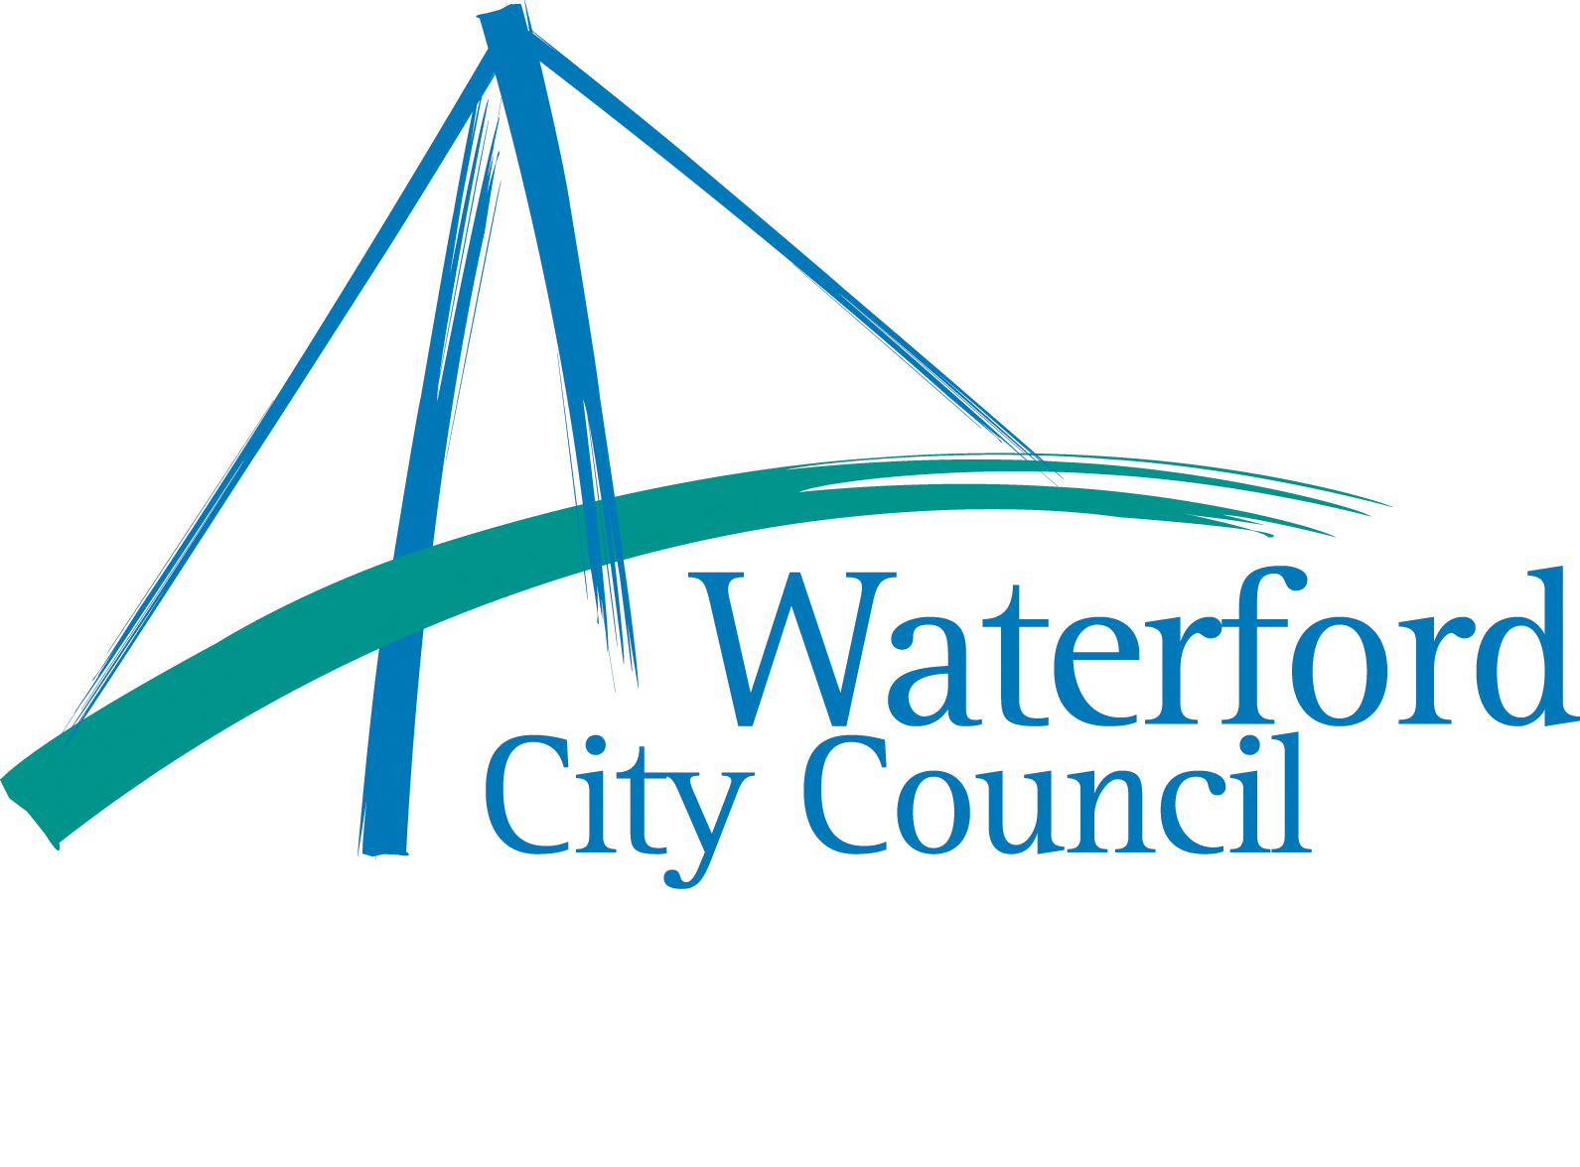 Waterford 
Sports Summer Camps



Information Directory 2004

Compiled By:

Waterford Sports Partnership Waterford Sports Partnership
Sports Development Office Civic Offices
Waterford City Council Dungarvan
The Mall Co. Waterford
Waterford 058 - 21192
051 – 860871

Waterford Sports Partnership in partnership with Waterford City Council have complied this directory as a source of information for those wishing to make contact with organisers of Sports Camps around Waterford. Inclusion in this directory is not an indicator of the quality or value of the camp. All camps listed are independently run and all related queries should be directed to the camp contact as listed.

The information directory is organised as follows:

Page Number
Section 1-

Extract from The Code of Ethics and Good Practice for Children’s Sport 2
In Ireland (Parents)

Section 2 –

When are the camps on?

List of dates when various camps are on. 4

Section 3 –

More detail on camps
Contact details, age group, cost, location etc for each individual camp.
All camps are listed in alphabetical order with all GAA camps listed on the
back page. 7

This information directory is available to download on Waterford Sports Partnership’s website www.waterfordsportspartnership.ie or to receive a copy by e-mail or post please contact our office at 058 - 21192.

Section 1

Extract from The Code of Ethics & Good Practice for Children’s Sport in Ireland (Parents’ Guide)

The Irish Sports Council and the Sports Council for Northern Ireland developed the Code of Ethics & Good Practice for Children’s Sport in Ireland to ensure a fun and safe sporting environment for children. While “The Code” is primarily aimed at the sports club environment, the guidelines below may also be useful for parents to apply to other sporting activities their children participate in.

Parents/Guardians have the primary responsibility for the care and welfare of young people. As such there are a number of steps you can take to ensure a fun and safe sporting environment for children.

1. Examine the role you can play to enhance the quality of your child’s involvement in sport. Encourage your child to:
- Put in their best effort – have a go
- Improve their skills
- Make friends
- Play by the rules
- Appreciate/accept everyone in the group, regardless of ability, race, religion, gender etc.
- Accept winning and losing as part of the game

2. Examine your behaviour and involvement in your child’s sport. You should:
- Be a role model - your child will learn best by example
- Show appreciation of, and respect towards, sports officials and their decisions
- Encourage children to play within the rules
- Behave responsibly on the sidelines and in all interactions involving children
- Focus on the child’s efforts rather than on performance
- Focus on the fun and participation of the child in the activity
- Know the names and qualifications of the leader
- Liaise with the sports leaders in relation to the times, locations etc, of training sessions

Strike a Balance
We need to keep in mind the reasons why young people want to take part in sport.
They want to learn new skills, make new friends, be part of a group, to win and be successful, experience excitement, challenges and action. They need input and guidance by adults to achieve these aims but parents need to ensure that young people’s fun remains the central focus. In providing for the needs of young people in sport parents should not:
- Put undue pressure on the child to please or perform well
- Ridicule or yell at a child for making a mistake or losing a game
- Treat the club as a child-minding service
- Take a child’s safety for granted. Never ignore or dismiss genuine complaints or concerns expressed by a child which relate to his/her involvement in sport.

3. The Sports Leader is the other important influence on the child’s enjoyment of sport. It is important that we support the leader where possible. Parents should take note of the following aspects of the leader’s approach:
- The emphasis on fun as well as competition
- The opportunities for children to make friends and for everyone to be included
- The opportunities to improve skills
- The use of modified games or equipment, where possible

Communicate often with the leaders even though you may not be in a position to attend every session.
Show an interest in their efforts to make your child’s involvement in sport safe and enjoyable.
Show that you consider their role important - they are not baby-sitters.

4. Parents can work with the club/organisation to ensure that procedures of good practice are created and adhered to. Parents should:
- Check that the club has a copy of the Code of Ethics and Good Practice for Children’s Sport in Ireland. A copy will be made available to every club in the country. It will also be available on the Irish Sports Council’s web site
- Check that the Code has been adopted by the club
- Be willing to become a member of the club a d be committed to upholding a code of good practice
- Take a active interest or offer to help in the running of the club, club events or any sporting activities in which your child takes part
- Be willing to become the Club Children ’s Officer or offer to help the officer
- Be aware of their child’s training and/or competitive programmes and its suitability for the child
- Be aware of the club’s procedures and policies, in particular where changes are made that affect your child.

A copy of the “Code of Ethics and Good Practice for Children’s Sport” can be downloaded from the Irish Sports Council Website:
http://www.irishsportscouncil.ie

Section 2

When are the camps on?

WHEN | CAMP NAME
June 28th – July 2nd   | Dungarvan Summer Camp  Killotteran Riding School Summer Camp (3-day)  Lets Go Summer School  Oceanic Manoeuvres Surf School  Swish Basketball Camp  WIT Camp
July 5th – July 9th  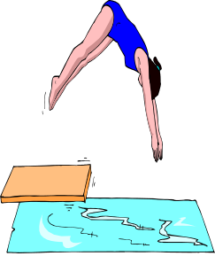 | Abbeyside GAA Camp  Dungarvan GAA Camp  Dungarvan Summer Camp  Dunmore East Adventure Centre Summer Camp  Killotteran Riding School Summer Camp (1-day)  Oceanic Manoeuvres Surf School  Pepsi FAI Camp (Ferrybank)  SAMBA Soccer – Johnville FC  Splash World Summer Camp  St. Paul’s GAA Camp  St. Saviour’s GAA Camp  Stretch -n- Grow  T-Bay Surf School and Surf Club  The Brill Dunhill Summer Camp  Tramore GAA Camp  Villa Football Club Summer Camp  Waterford Crystal Pool Swim Camp  WIT Camp  Xtra Kool Kidz
July 12th – July 16th   | Ballyduff Upper GAA Camp  Bohemians FC Summer Camp  Camp Waterford  Dungarvan Summer Camp  Dunmore East Adventure Centre Summer Camp  Lismore GAA Camp  Oceanic Manoeuvres Surf School  Pepsi FAI Camp (Tramore)  Rathgormack GAA Camp  Roanmore GAA Camp  SAMBA Soccer Johnville FC  St. Declan’s Community College  Stretch -n- Grow  T-Bay Surf School and Surf Club  The Brill Dunhill Summer  Tramore GAA Camp  Waterford Crystal Pool Swim Camp  WIT Camp  Xtra Kool Kidz

WHEN | CAMP NAME
July 19th –July 23rd   | Ballyduff AFC Summer Soccer Camp  Brickey Rangers GAA Camp  Butlerstown GAA Camp  Bohemians FC Summer Camp  Camp Waterford  Dunmore East Adventure Centre Summer Camp  Dunhill GAA Camp  Dungarvan Summer Camp  Killotteran Riding School Summer Camp (1-day)  Mount Sion GAA Camp  Oceanic Manoeuvres Surf School  SAMBA Soccer – Waterpark College  St. Declan’s Community College  St. Oliver’s GAA Camp  St. Stephen’s (DLS) GAA  T-Bay Surf School and Surf Club  The Brill Dunhill Summer Camp  Tramore GAA Camp  Waterford Crystal Pool Swim Camp  WIT Camp
July 26th – July 30th   | Cappoquin GAA Camp  Dungarvan Summer Camp  Dunmore East Adventure Centre Summer Camp  Gaultier GAA Camp  Killotteran Riding School Summer Camp  Kilrossanty GAA Camp  Oceanic Manoeuvres Surf School  Pepsi FAI Camp (Waterford Bohemians)  St. Declan’s Community College  T-Bay Surf School and Surf club  The Brill Dunhill Summer Camp  Waterford Crystal Pool Swim Camp  WIT Camp
August 2th – August 6th   | Dunmore East Adventure Centre Summer Camp  Killotteran Riding School Summer Camp (2-day)  T-Bay Surf School and Surf camp  The Brill Dunhill Summer Camp  Oceanic Manoeuvres Surf School  Waterford Crystal Pool Swim Camp
August 9th – August 13th   | Dunmore East Adventure Centre Summer Camp  Ferrybank GAA Camp  Oceanic Manoeuvres Surf School  St. Mary’s GAA Camp  T-Bay Surf School and Surf Camp  The Brill Dunhill Summer Camp  Waterford Crystal Pool Swim Camp  WIT Camp

WHEN | CAMP NAME
August 16th – August 20th   | Ballygunner GAA Summer Camp  Ballymacarbry GAA Camp  Clonea GAA Camp  Dunmore East Adventure Centre Summer Camp  Kilmacthomas GAA Camp  Oceanic Manoeuvres Surf School  Pepsi FAI Camp Dungarvan  Sacred Heart GAA Camp  St. Patricks/Naomh Brid GAA Camp  The Brill Dunhill Summer Camp  T-Bay Surf School and Surf Camp  Waterford Crystal Pool Swim Camp  WIT Camp
August 23rd – August 27th   | Cois Brid GAA Camp  St Declans (De La Salle) GAA Camp  Dunmore East Adventure Centre Summer Camp  Killotteran Riding School Summer Camp  Oceanic Manoeuvres Surf School  Portlaw GAA Camp  St Declan’s GAA Camp  T-Bay Surf School and Surf Camp  The Brill Dunhill Summer Camp  Waterford Crystal Pool Swim Camp

WANT TO KNOW MORE? KEEP READING

Section 3
More details of camps listed
(In alphabetical order with GAA camps on the back page)

CAMP NAME | TELL ME MORE!
Ballyduff Summer Soccer Camp   | Age Group: 8-13 years  Location: St. Nicholas Park, Ballyduff AFC, Kilmeaden.  Time: 1.30pm to 4.30pm daily  Cost: €50 per week. Family rates available on request.  Extra details: Each participant should bring football boots/ trainers and playing gear. The camp will provide the kids with soccer coaching and fun games.  Contact: Anthony Carlin 051- 384060; Stephen Flynn 051 – 384569
Bohemians FC Summer Camp   | Age Group: Boys 6 – 15 years; Girls 6 – 12 years  Location: Waterford Crystal Sports Complex  Time: 10am to 2pm daily  Cost: €70 per week. Family rates available on request.  Extra details: Each participant should bring football boots, trainers and playing gear. The camp provides the kids with a good base knowledge of the skills and tactics involved in the game of soccer whilst also incorporating fun events. Camps have access to both indoor and outdoor facilities so weather is not a problem. This year as well as skills coaching there will be a variety of fun events.  Contact: Davy Mulcahy 051- 858533; Derek Chesnutt 051 – 8431646 (H)/332246(W); Richie Elliot 051 – 375542 or any committee member
Camp Waterford   | Age Group: 6 – 14 years  Location: Newtown school  Time: 10am – 4pm daily  Cost: (includes free T-shirt):  Per Child €25 per day, €95 per Wk (€180/2 wks)  Family of 3:Per child:€20 per day, €85 per Wk (€160/2 wks)  Extra Details: Experienced and qualified staff offer a wide variety of sports using the indoor swimming pool, tennis courts, sports hall and all weather pitches. Also available are arts & crafts, board games, quizzes and treasure hunts.  Contact: Chris and Rachel Guest 051 – 873752 www.campwaterford.com
Dungarvan Summer Camp   | Age Group: 6-15 Years  Location: Dungarvan Sports Centre  Time: 10am-4pm daily  Cost: One Child €70, 2 children €120, 3 children €165 (extra cost for bus)  Extra Details: In addition to the full programme of sports, games and daily swimming, this year there will be a greater emphasis on arts, crafts and drama.  Buses will be provided from various locations around Waterford  Contact : The Manager, Dungarvan Sports Centre 058 41111
CAMP NAME | TELL ME MORE!
Dunmore East Adventure  Summer Camp   | Age group: 5-17 Years (Star Fish 5-7, Sharks 8-13, Adventurers 14-17)  Location: Dunmore East Adventure Centre  Time: 10am – 3pm daily  Cost: Star Fish €140pw, Sharks €160pw, Adventurers €190pw  Extra Details: These are multi-activity camps including activities such as kayaking, canoeing, windsurfing, sailing, archery and rock climbing depending on age.  Contact: Rupert Musgrave 051-383783  E-mail: info@dunmoreeastadventurecentre.com  Web: www.dunmoreeastadventurecentre.com
Killotteran Riding School  Summer Camp   | Age group: 6+ years  Location: Killotteran Riding Centre  Time: 10am – 4.00pm daily  Cost: 1-day camp €45, 2-day camp €85, 3-day camp €110, 5-day camp €160  Extra details:  Horse riding lessons for all from beginners to more experienced.  Contact: Helen Deevy 051-384712
Lets Go Summer Schools   | Age Group: 5-12 years  Location: Tramore CBS Secondary School  Time: 9.30am - 3.30pm daily  Cost: €70  Contact: Eileen Sheehy/Kevin O’Brien 021-4877111  E-mail: info@letsgo.ie  Web: www.letsgo.ie
Oceanic Manoeuvres Surf  School   | Age Group: 7 - 17 years  Location: The Red Cottage, Tramore  Time: 10am – 12.30pm (7-14 yrs) 4pm-6pm (14-17 yrs) daily  Cost: €75 for 5 days; €17 per day; 10 day pass available  Extra Details: Learn to surf with experienced instructors in a safe and fun environment.  Beach Camp (7-12yrs) a fun introduction to waves and the sea.  Surf Camp (7-14 yrs) concentrates on surfing while building confidence in waves through fun and instruction.  Youth Zone (14-17 yrs) progressing surfing techniques, beginner, improver and elite levels  Contact: Linda Tuohy 051-390944
Pepsi FAI Summer Soccer  Schools   | Age Group: 7 – 15 years  Location: Bohemians FC at Waterford Crystal, Ferrybank FC & Tramore FC  Time: 10am – 3.30pm daily  Cost: €79 per week  Extra Details: The programme is designed to deliver 5 football packed days of fun, skills and games. Under the direction of the FAI technical director the coaching programme is delivered by FAI qualified coaches. Each participant receives a special edition full playing kit, football, soccer superskills DVD, waterbottle and certificate of participation.  Contact: 1890 653 653
CAMP NAME | TELL ME MORE!
St. Declan’s Community  College Kilmacthomas | Age Group: 6-12 years  Location: St. Declan’s Community College Kilmacthomas  Time: 10am – 3pm daily  Cost: €60. Family discount available.  Extra Details: Camps include sports and arts and crafts.  Week 1 (12th-16th) is a ‘get to know you camp’ for incoming first years.  Contact: Aine Cummins 051-294100
Samba Soccer Camp   | Age Group: 5 – 13 years  Location: Johnville FC, Waterpark College, Dungarvan AFC  Time: 9am – 3pm daily  Cost: €90 before May 5th; €95 after  Extra Details: Each player will be challenged to explore his/her natural talents, while achieving a degree of success at their own level of ability in a non competitive environment. The players are divided into age and skill related groups. The camp includes an hour and a half of multi activity in the morning with the remainder being soccer related. Cost includes SAMBA pack and 5 days coaching.  Contact: SAMBA Soccer School 01 – 4972455
Splash World Summer Camp   | Age Group: 5-12 years  Location: Splash World Tramore  Time: 9.30am – 12.30pm daily  Cost: €40 (€35 for additional family members)  Extra details: The first hour is swim instruction and then the remaining hours are full of games and activities.  Contact: Gaye McCauliffe 051-390176
Stretch and Grow   | Age Group: 3-7 years  Location: Ardkeen Community Meeting Room  Time: 11-1am daily  Cost: €55  Extra Details:  www.stretch-n-grow.ie  Contact: Sarah Jane Hogan Sarahjanehogan@eircom.net
Swish Basketball Camp   | Age Group: 11 – 17 years  Location: Presentation Secondary School, Waterford  Time: 10am – 4pm daily  Cost: €70  Extra Details: The individual camp is for boys and girls wishing to learn and develop their shooting, passing, dribbling and rebounding skills. The team camp is for school and club teams of boys and girls. Teams of 12 players work together on individual play and team offences and defences.  Contact: Gerry Fitzpatrick 051 - 870768

CAMP NAME | TELL ME MORE!
T-Bay Surf School and Surf Club   | Age Group: 8-10 years and 11-17 years  Location: T-Bay Surf and Wildlife Centre, On the Beach, Tramore  Time: 10am-12.30pm (Junior) 2-4.30pm (Teenager) daily.  Cost: €55  Extra Details:  All equipment supplied. The camp is delivered by I.S.A. qualified surf coaches. Purpose built surfing facility on the beach in Tramore.  (T-Bay Surf and Wildlife Centre also run a Wildlife Explorer Club Summer Camp.)  Contact: Billy Butler 051 391297
The Brill Dunhill Summer  Camp | Age Group: 5-12 years  Location: Dunhill Health and Leisure Centre  Time: 10am – 3.30pm daily  Cost: €60 per wk; €50 for 2nd child  Extra Details: The camp offers 70 activities ranging from sports such as volleyball, basketball,soccer to arts and crafts, adventure activities and entertainment events.  Contact: Julie Torpey or Barry O’Connor 051 –396333
Villa Football Summer Camp | Age Group:  Location: Villa FC Grounds, Connors Park, Ozier Terrace, Waterford  Time: 10.00am – 2.30pm daily  Cost: €60 (reduction for more than one child in the same family)  Extra Details: Football coaching, skills and a variety of football based games. The club’s games room (including pool tables and table tennis) will also be available which means bad weather will not stop the fun!  Contact: Paul Morrissey 087-6744798
Waterford Crystal Pool Swim  Camp  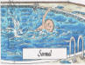 | Age Group: 4-12 years  Location: Waterford Crystal Sports Centre (Swimming Pool)  Time: 1-hour lesson available at 9.30, 10.15 or 11.15  Cost: €50 for 10 lessons  Extra Details: A one-hour lesson for 10 mornings on learning how to swim at all levels with instructors.  Contact: Reception Waterford Crystal Sports Centre 051-377905
Waterford Institute of  Technology (WIT)   | Age group: 6-15 years  Location: Waterford Institute of Technology  Time: 10am – 4.30 pm daily  Cost: €85 per week; each subsequent week €80  Extra Details:  Extra morning supervision from 8.45am-9.45am (€10)  Offers Children’s Programme (5-12 years) and Teenagers Programme (13 –16 years). Camp offers a varied programme which includes sport & fun, arts & crafts, computers, and leisure & field trips.  Contact: Clubs and Societies Office WIT 051 – 302238

CAMP NAME | TELL ME MORE!
Waterford Street Awareness  Kick Boxing Centre   | Age Group: 6 years +  Location: Mount Sion CBS  Time:10am – 12 noon daily  Cost: €30 per camp (family discount available)  Extra Details: Street awareness deals with self – defence, kick boxing, bullying prevention and other activities.  Contact: Billy O’Sullivan 051 – 356476 / 087 - 6743384
Xtra Kool Kidz   | Age Group: 6-14 years  Location: Ursline Convent, Sports Hall  Time: 10am – 3 pm daily  Cost: €70 per week. Reduction for 2 children  Extra details: Multi Sports Camp  Contact: Siobhan Furlong, 087 4122865 Eilis Strappe 086 8517663

CAMP NAME | TELL ME MORE!
Waterford GAA Camps   | Age Group: 6 – 13 years  Location: See Table Below  Time: 10am – 2.30pm daily  Cost: €45  Extra Details: is designed to deliver 4 hurling and Gaelic football filled days of fun, skills and games. The summer camps are under the direction of the 4 games promotion officers and their team of qualified coaches. Each participant will receive a special edition GAA kit, gear bag and 18 hours of qualified coaching.  Camp Location Local Co-ordinator Telephone Number  Abbeyside Johnathon O’Donovan 058-44692  Ballyduff Upper Gretta Kearney 058-60324  Ballygunnar Gail O’Sullivan 087-2992775  Ballymacarbry Paddy O’Grady 087-663760  Brickey Rangers Angela Whelan 058-45810  Butlerstown Angela Costello 051-384515  Cappoquin Mike Murray 058-54339  Clonea Tom Finn 051-641639  Cois Brid Eamon Lonergan 024-97417  Dunhill Martina Burns 051-396289  Dungarvan Brian Sheehan 058-45145  Ferrybank Rosemarie Heffernan 051-832574  Gaultier Pauline Murphy 087-9131119  Kilrossanty Pat Prendergast 051-291373  Kilmacthomas Lisa Cronin 051-294140  Lismore William Leahy 058-53139  Mount Sion Pat Carroll 086-3764911  Portlaw Daithi Foran 051-387474  Rathgormack Ann Terry 051-646713  Roanmore Gwen O’Connell 051-850056  Sacred Heart Michael Power 087-6647480  St. Declan’s Eamon Fitzgerald c/o St. Declan’s School  St. Mary’s Siobhan Keane 051-387627  St. Olivers Michael Phelan 058-68231  St. Patrick/N.Brid Mary Fahey 087-2813935  St. Pauls Sean Reinhart 051-352224  St. Saviours Mark Corcoran 086-2203112  St. Stephen’s (DLS) Billy Flynn 051-354008  Tramore Con Daly 051-390816  Contact:  Local club co-ordinator or one of the Games Promotion Officers  Michelle Power 086 6076226, Brendan McKeogh 086 2390763, Fergus Ryan 086 6089413, Kieran O’Gorman 0863941861  Email: watefordgpo@yahoo.com  Website: www.waterfordgaaonline.com

